***Final team Project Group15***

**MySQL Queries Description and sample queries**

1.1 Discipline from School Administrator perspective:

For each facility, how many students violate the discipline per year?

use Schools_K12_DW;

select df.FacilityName,count(fd.StudentID) as DisciplineStudentNumber,

year(fd.EventDate) AS Year

from factDiscipline as fd join

dimFacility as df

on fd.EventFacilityID= df.FacilityID

group by df.FacilityName,year(fd.EventDate)

order by year(fd.EventDate),DisciplineStudentNumber DESC

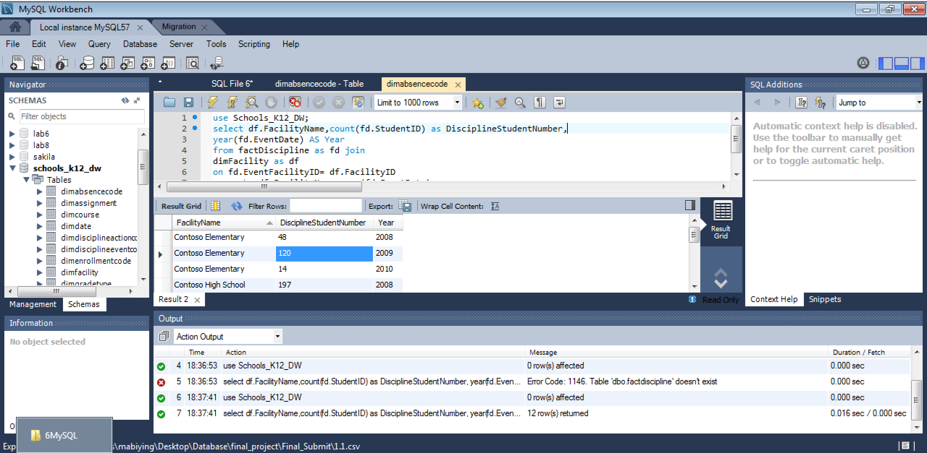

1.2 Student Discipline from parents perspective:

Order the top common Discipline Events

use Schools_K12_DW;

select dde.DisciplineEventCode, dde.DisciplineEventDesc, count(ds.StudentID) as DisciplineStudentNumber

from factDiscipline as fd join

dimDisciplineEventCode as dde

on dde.DisciplineEventCodeID=fd.DisciplineEventCodeID join

dimStudent as ds

on ds.StudentID = fd.DisciplineEventCodeID

group by dde.DisciplineEventCode, dde.DisciplineEventDesc

order by DisciplineStudentNumber DESC

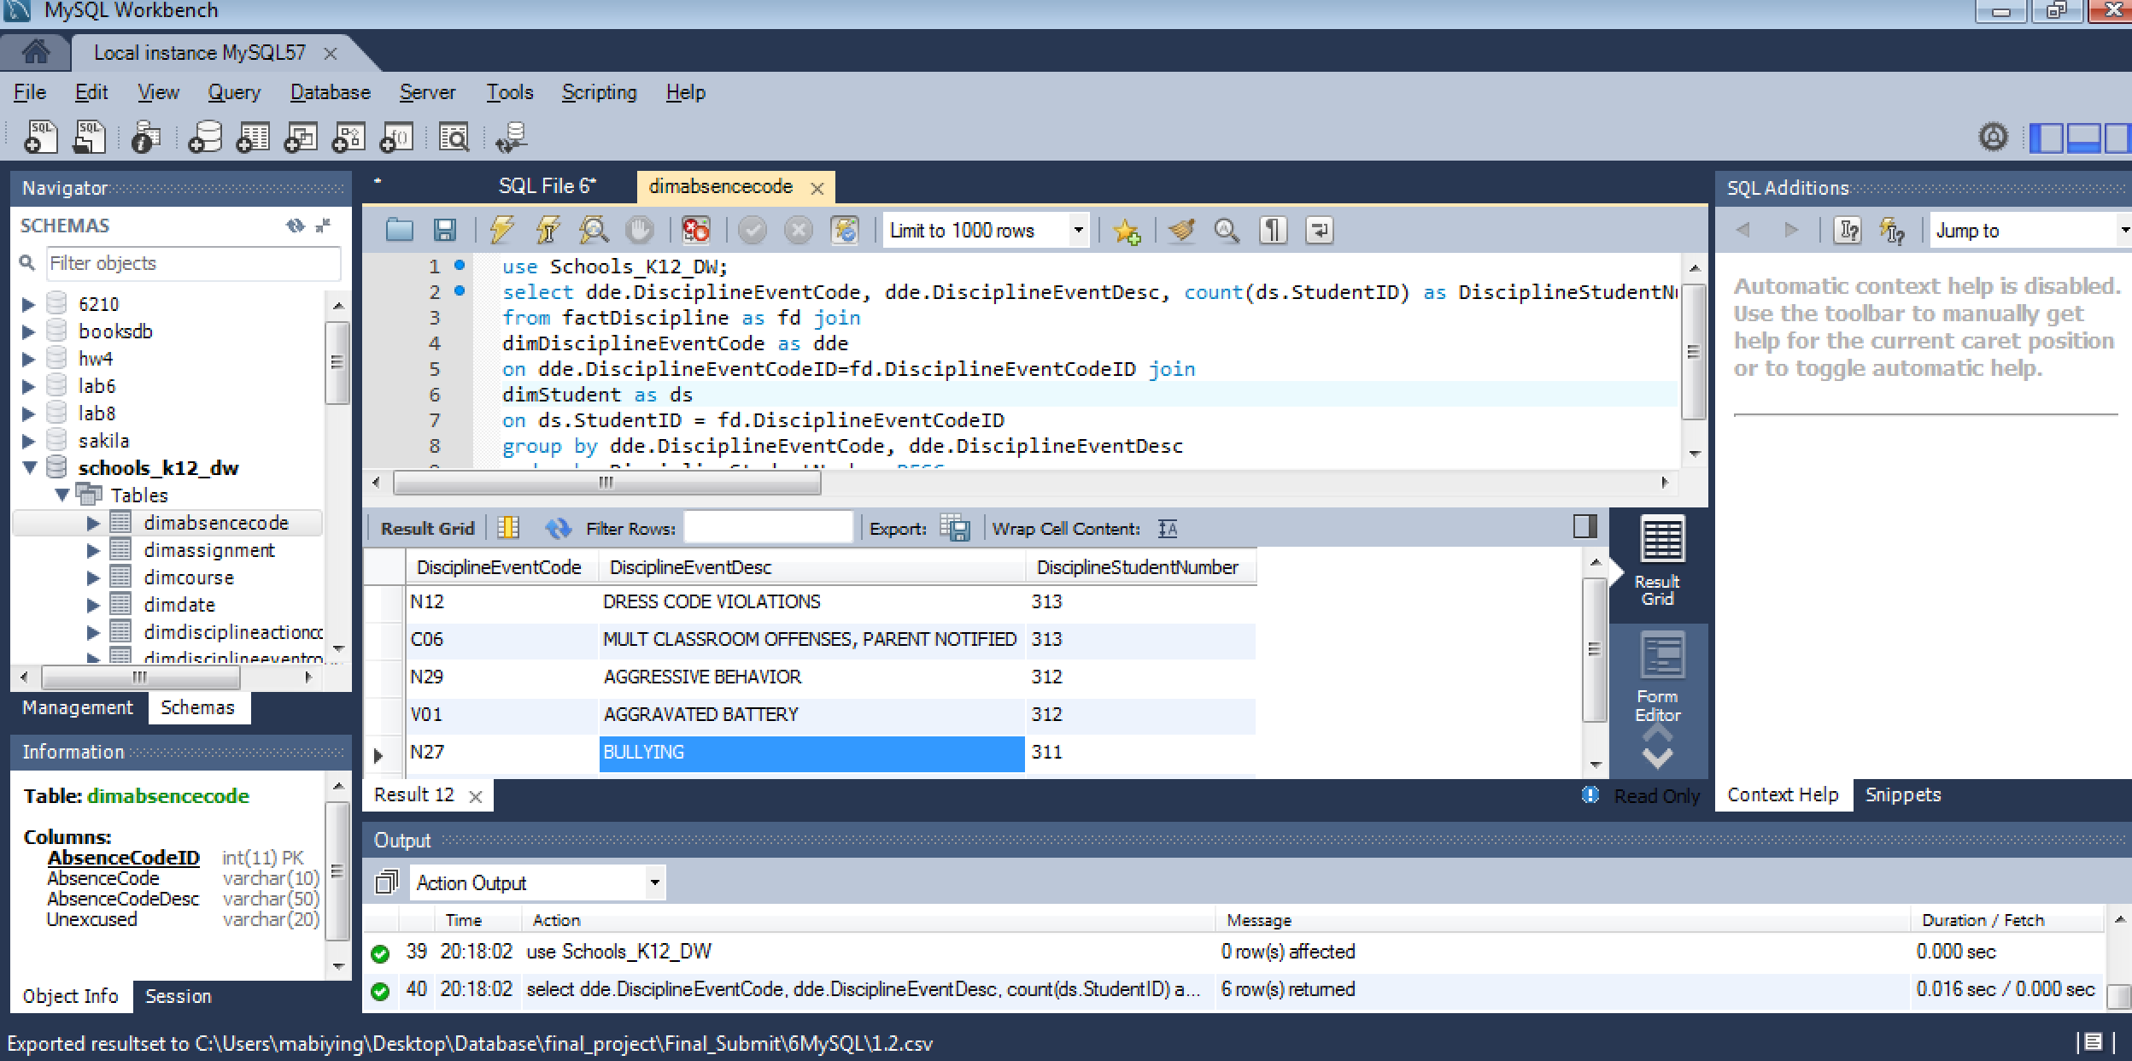

1.3 Student Discipline from teachers perspective:

Order the discipline Events reported by staff

use Schools_K12_DW;

select distinct dde.DisciplineEventCode, dde.DisciplineEventDesc, count(ds.StaffID) as DisciplineStaffNumber

from factDiscipline as fd join

dimDisciplineEventCode as dde

on dde.DisciplineEventCodeID=fd.DisciplineEventCodeID join

dimStaff as ds

on ds.StaffID= fd.EventReportingStaffID

group by dde.DisciplineEventCode, dde.DisciplineEventDesc

order by DisciplineStaffNumber DESC

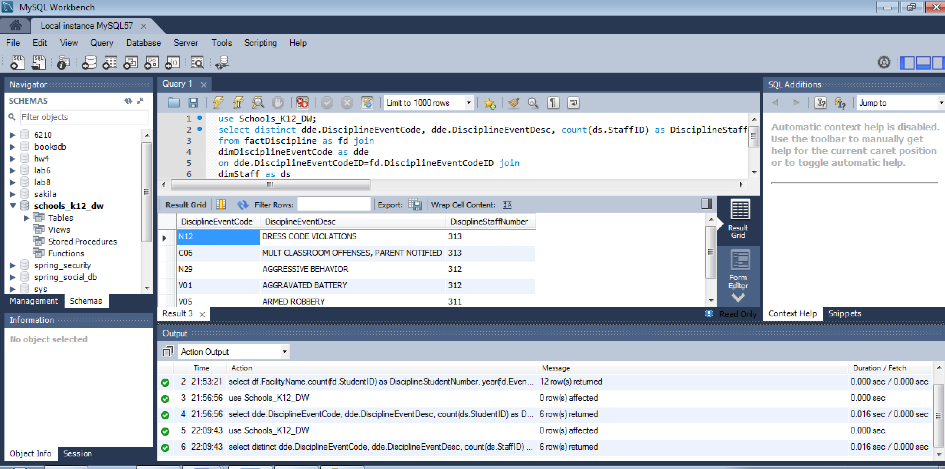

2.1 Student Absences from School Administrator perspective:

How many absent students are there in each facility?

use Schools_K12_DW;

SELECT df.FacilityName , count(dd.StudentID) as AbsentStudentNumber

FROM

factAbsence fb join

dimStudent dd on

fb.StudentID = dd.StudentID join

dimFacility df on

df.FacilityID = dd.FacilityID

Group by df.FacilityName

order by AbsentStudentNumber DESC

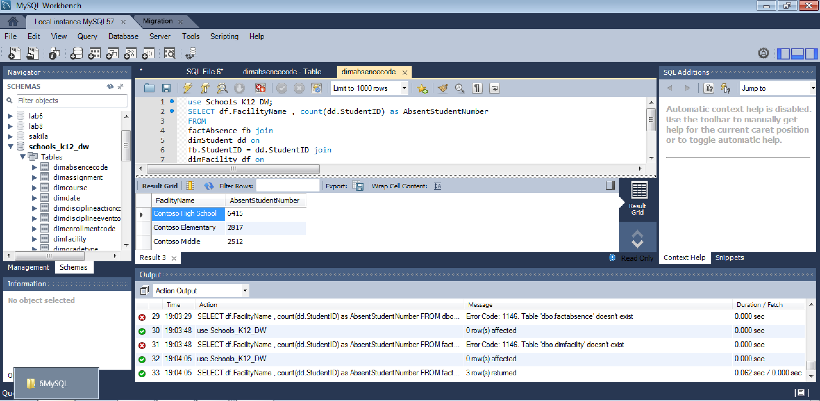

2.2 Student Absences from teachers perspective:

order the number of absent students of staff

use Schools_K12_DW;

SELECT ds.StaffID , count(ds.StaffID) as AbsentStaffNumber

FROM

factAbsence fb join

dimStaff ds on

fb.StaffID= ds.StaffID

Group by ds.StaffID

order by AbsentStaffNumber DESC

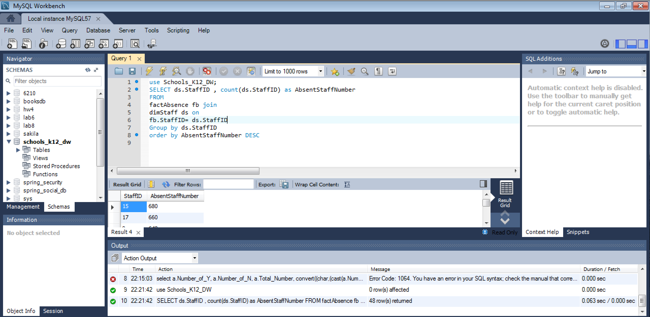

2.3 Student Absences from parents perspective:

order the reason why students are absent

use Schools_K12_DW;

select da.AbsenceCodeDesc, count(ds.StudentID) as AbsentStudentNumber

from factAbsence as fa join

dimAbsenceCode as da

on da.AbsenceCodeID=fa.AbsenceCodeID join

dimStudent as ds

on ds.StudentID = fa.StudentID

group by da.AbsenceCodeDesc

order by AbsentStudentNumber DESC

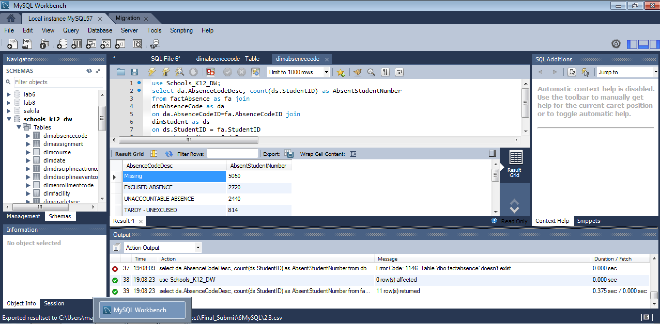

3.1 Academic performance from School Administrator perspective:

For each facility, list average raw score and scaled score for every subject

use Schools_K12_DW;

select df.FacilityName,fsd.SubjectID,

AVG(fsd.ScaledScore) as ScaledScore,

AVG(fsd.RawScore) as RawScore

from factStandardizedTestScore as fsd

join dimStudent as ds on

ds.StudentID=fsd.studentID join

dimFacility as df on

ds.FacilityID = df.FacilityID

group by df.FacilityName,fsd.SubjectID

order by df.FacilityName

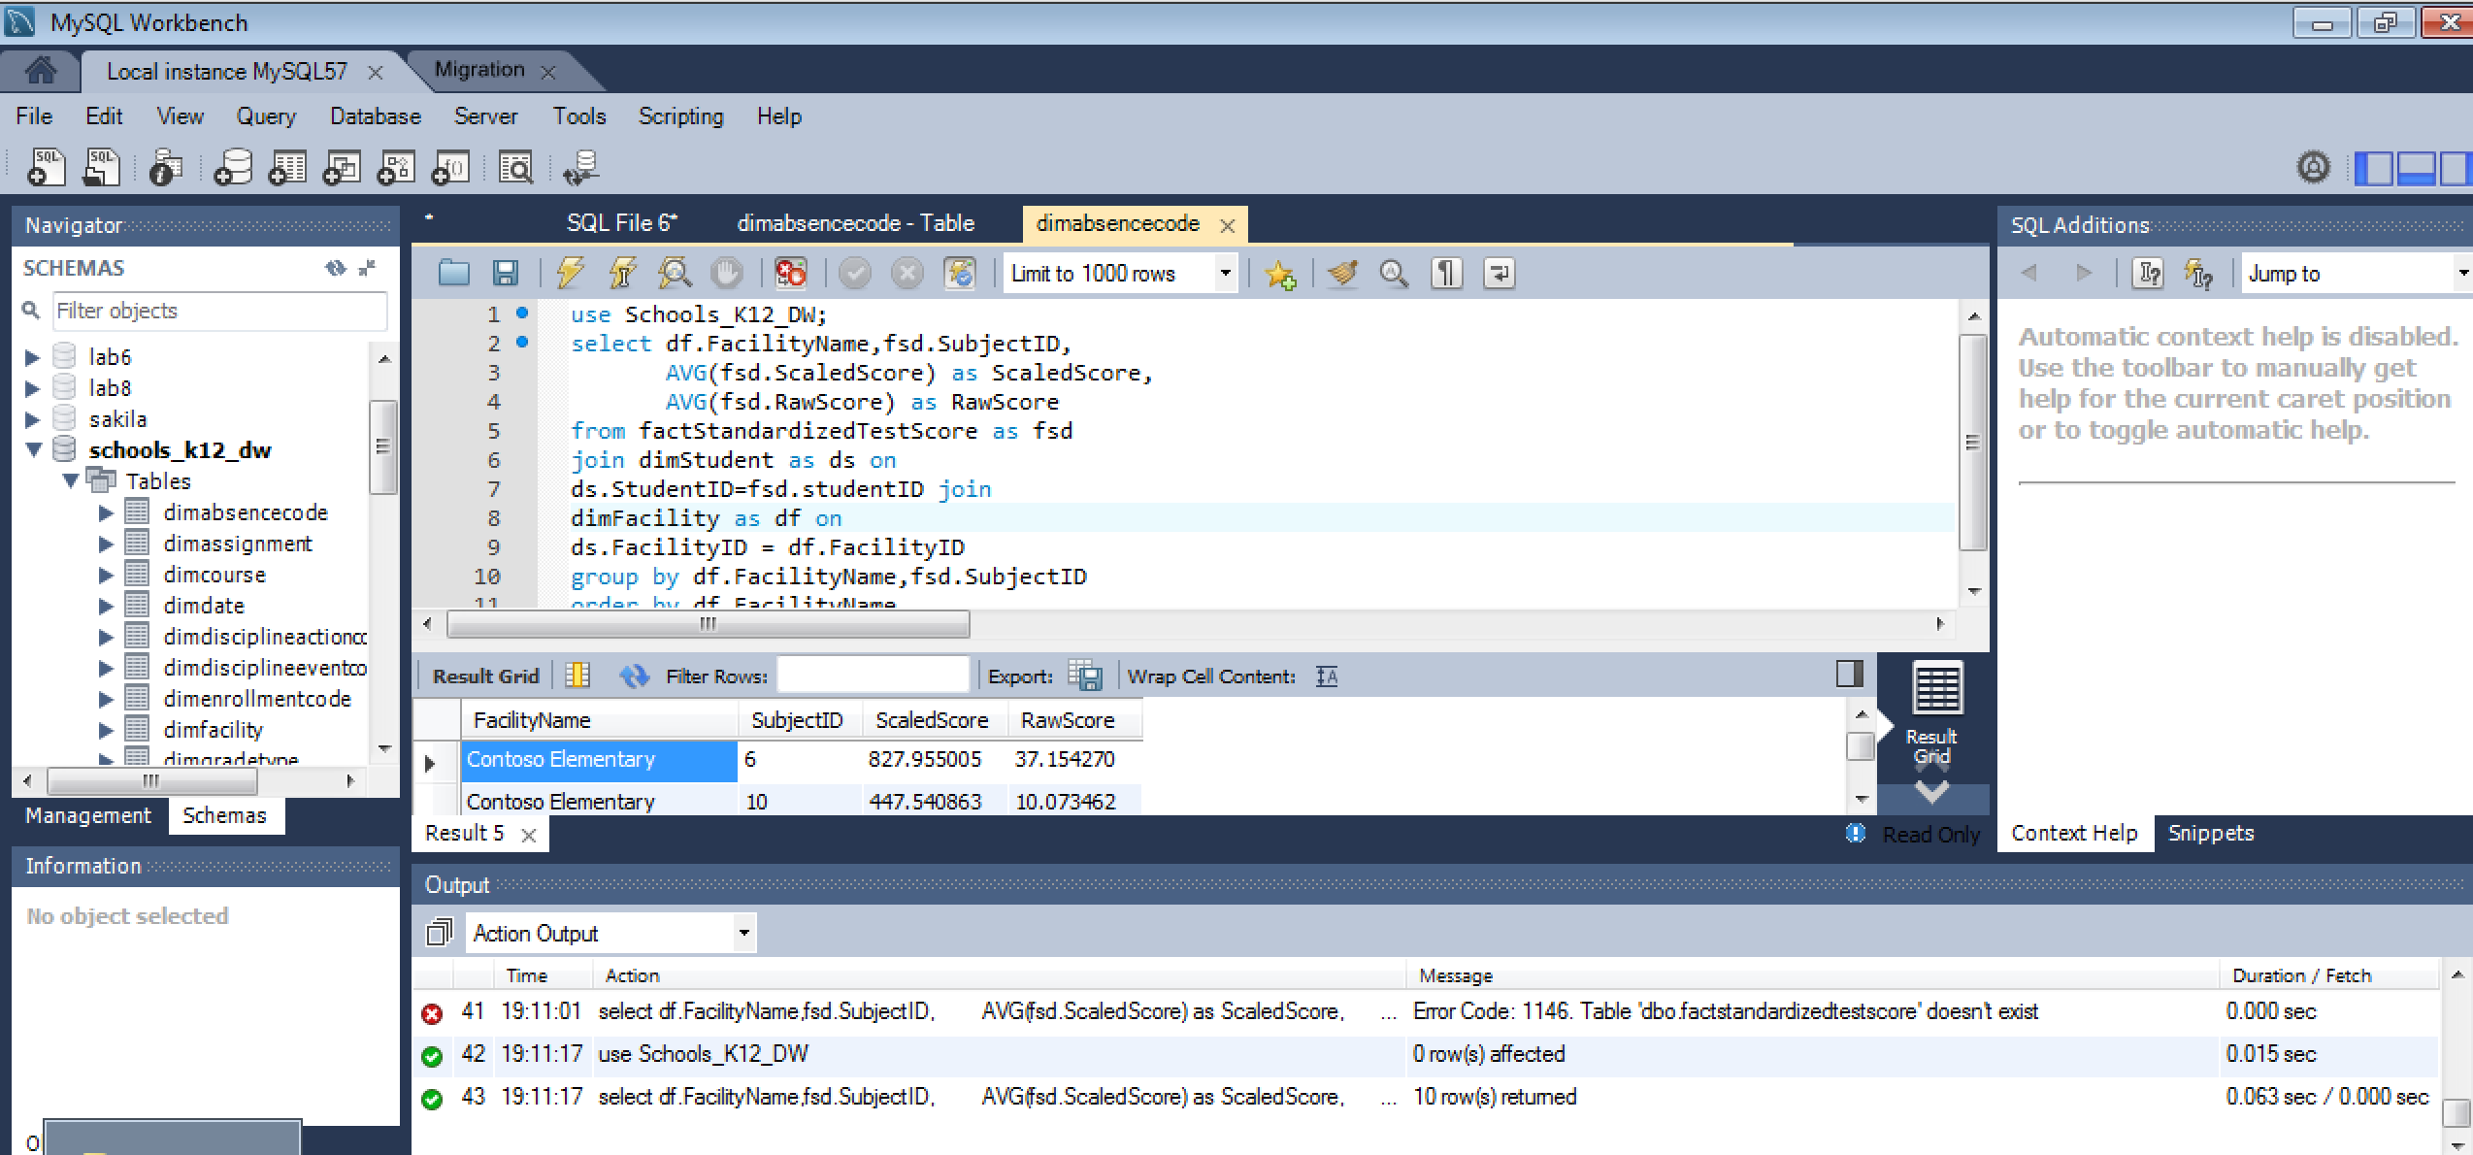

3.2 Academic performance from teachers perspective:

Average numeric grade of students for each course

use Schools_K12_DW;

select dc.CourseID,dc.CourseTitle,avg(fscg.NumericGrade) as AverageScore

from factStudentCourse as fsc join

dimCourse as dc on

fsc.CourseID = dc.CourseID join

factStudentCourseGrade as fscg

on fscg.StudentCourseID = fsc.StudentCourseID

group by dc.CourseID,dc.CourseTitle

order by avg(fscg.NumericGrade) desc

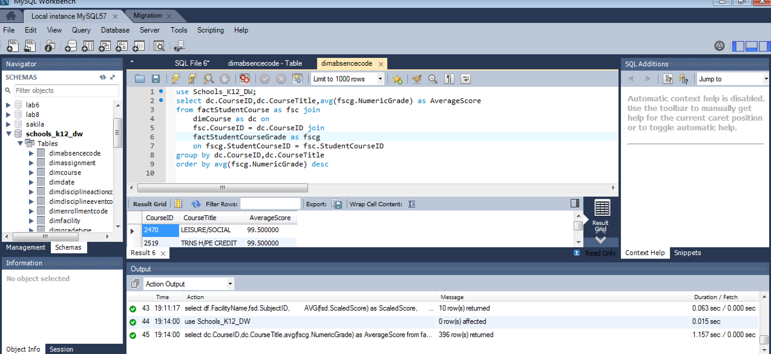

3.3 Academic performance from parents perspective:

Rank student average course score by course

use Schools_K12_DW;

select dc.CourseTitle,ds.StudentID,ds.StudentName,avg(fscg.NumericGrade) as AverageScore,

@curRank := @curRank + 1 AS RankByScore

from factStudentCourse as fsc join

dimstudent as ds on

fsc.StudentID = ds.StudentID join

dimCourse dc on

fsc.CourseID = dc.CourseID join

factStudentCourseGrade as fscg on

fsc.StudentCourseID = fscg.StudentCourseID,

(select @curRank :=0) r

group by ds.StudentID,ds.StudentName, dc.CourseTitle

order by avg(fscg.NumericGrade) desc

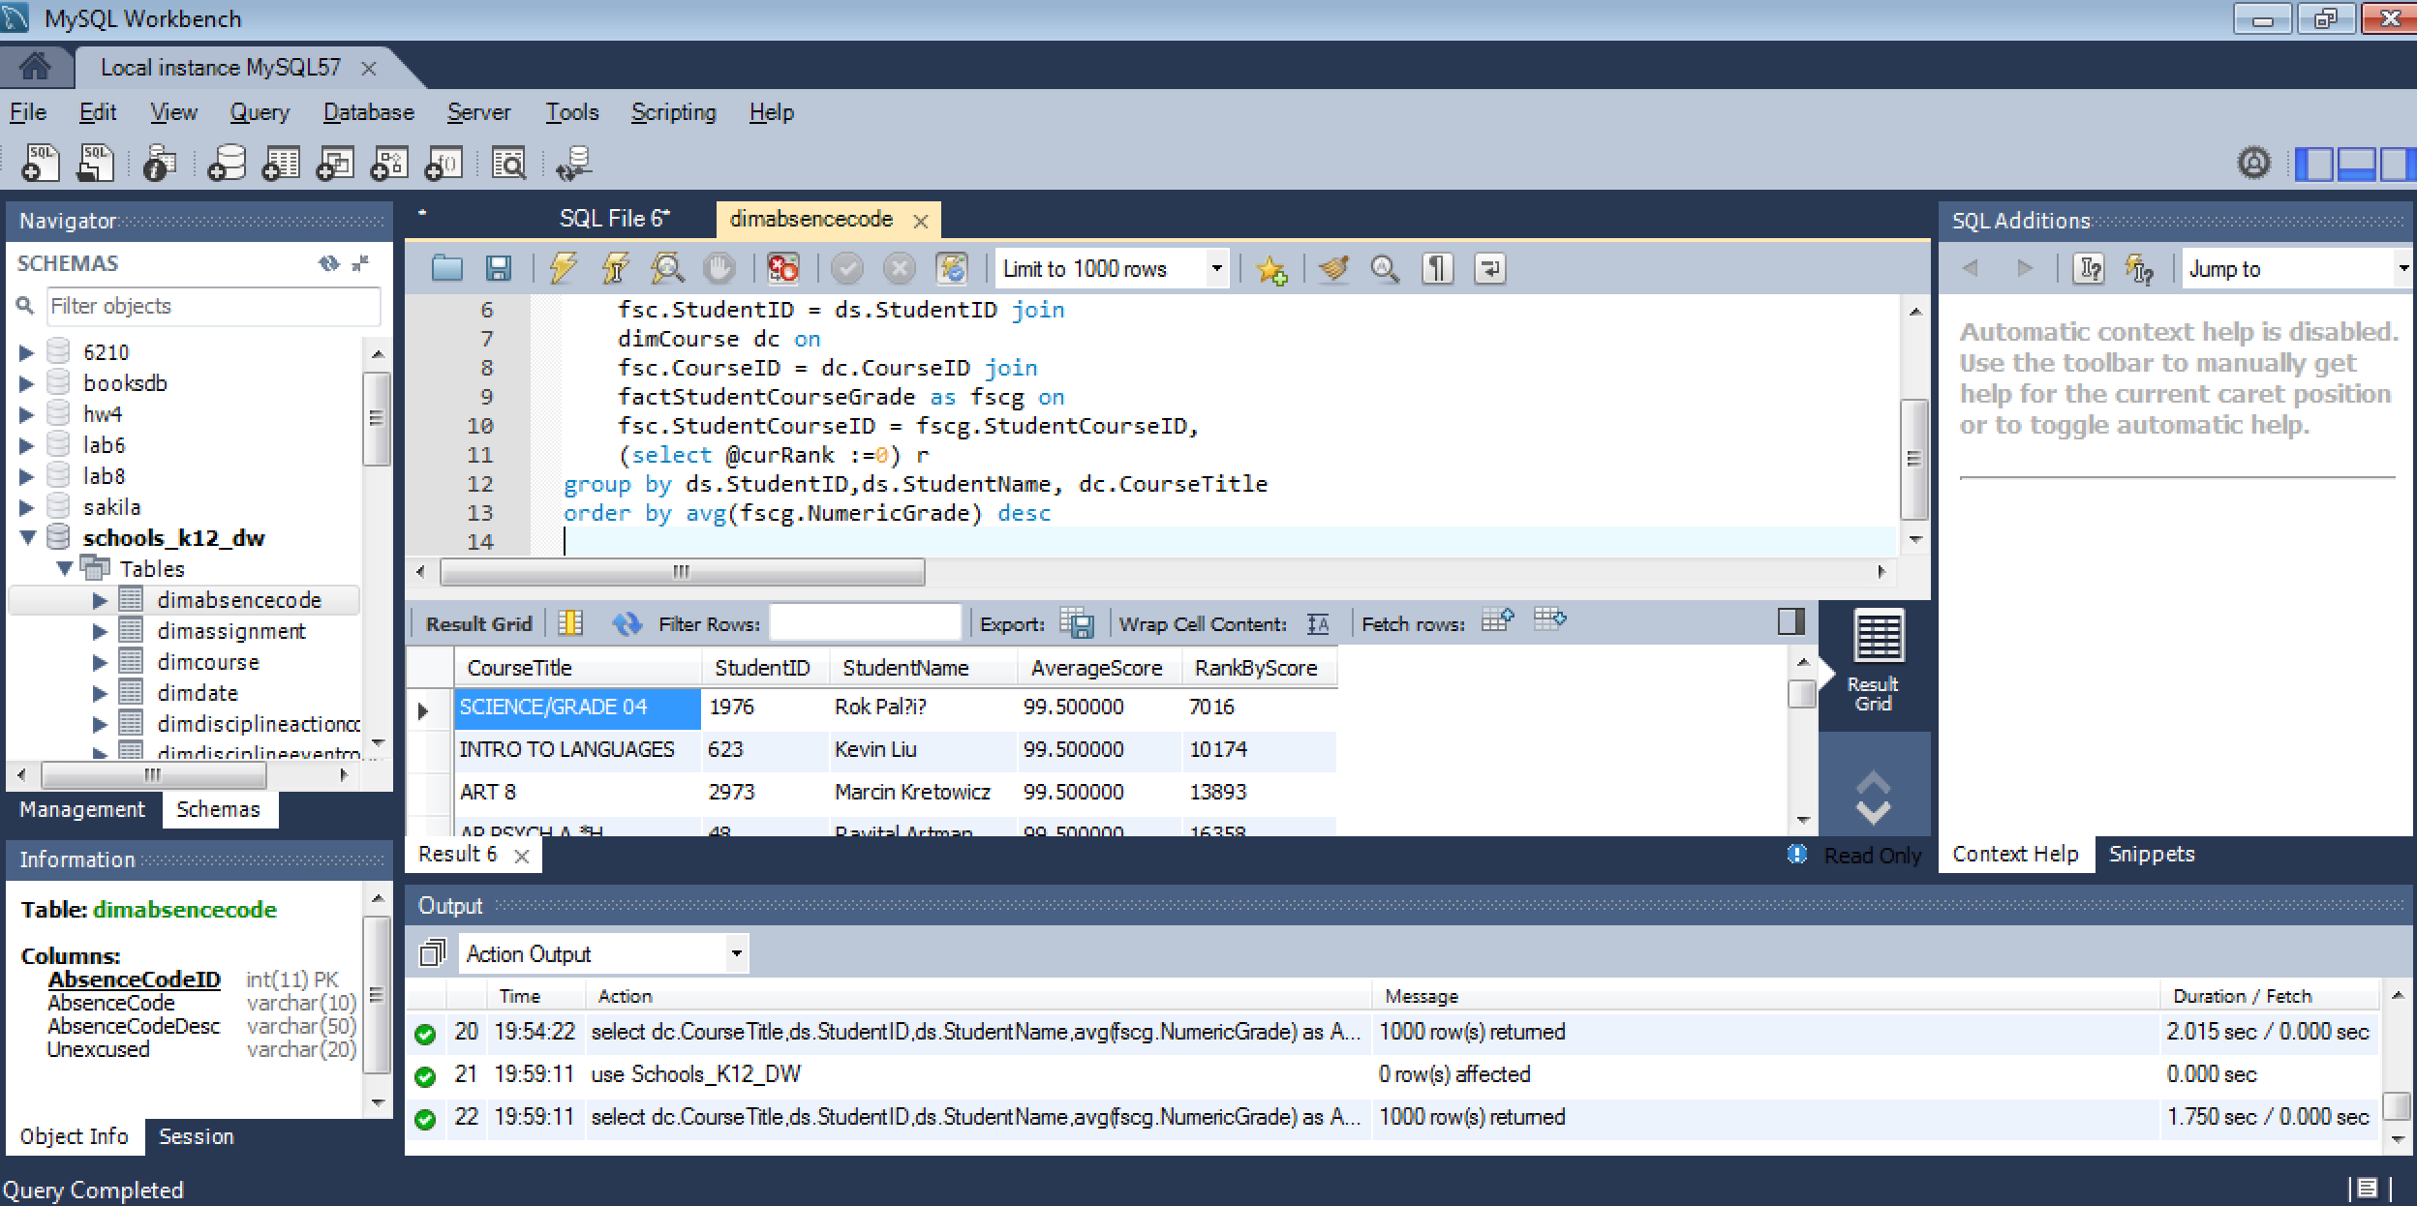

4.1 Special Programs from School Administrator perspective:

How many Special Programs are there in every facility per year?

use Schools_K12_DW;

select df.FacilityName,count(fsp.SpecialProgramID) as SpecialProgramNumber,

year(fsp.EntryDate) AS Year

from factSpecialProgram as fsp join

dimStudent as dS

on fSP.StudentID= dS.StudentID JOIN

dimFacility as df on

df.FacilityID = ds.FacilityID

group by df.FacilityName,year(fsp.EntryDate)

order by year(fsp.EntryDate),SpecialProgramNumber DESC

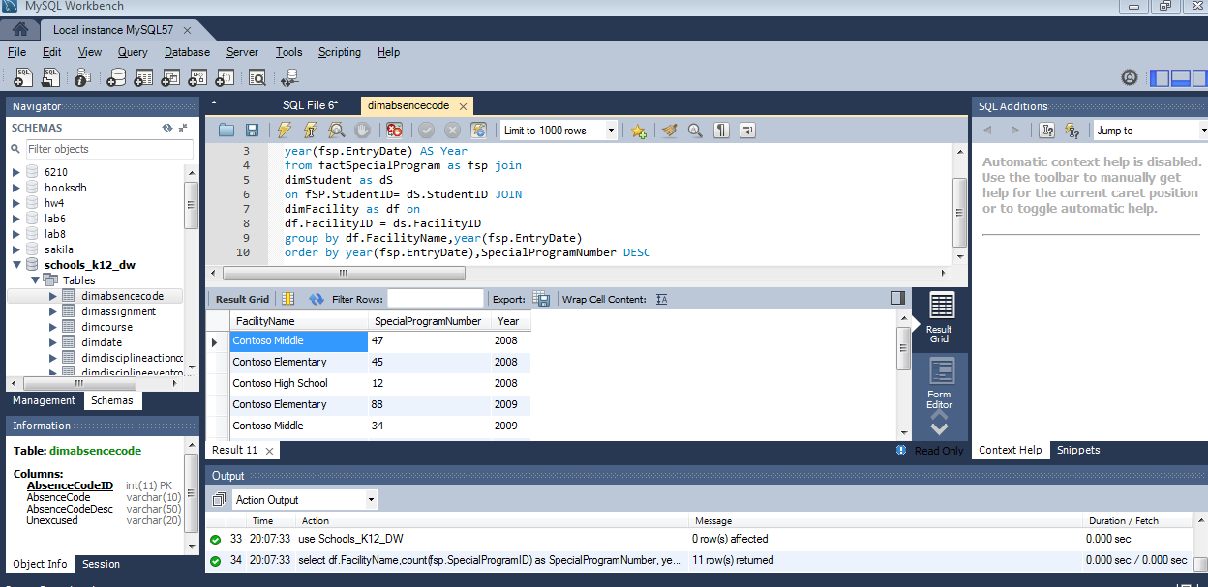

4.2 Special Programs from teacher perspective:

How many Special Programs are there in every program?

use Schools_K12_DW;

select fsp.ProgramID,dsp.ProgramCode,count(fsp.SpecialProgramID) AS SpecialProgramNumber

from factSpecialProgram as fsp join

dimSpecialProgram as dsp on

dsp.ProgramID = fsp.ProgramID

group by fsp.ProgramID,dsp.ProgramCode

order by SpecialProgramNumber DEsc

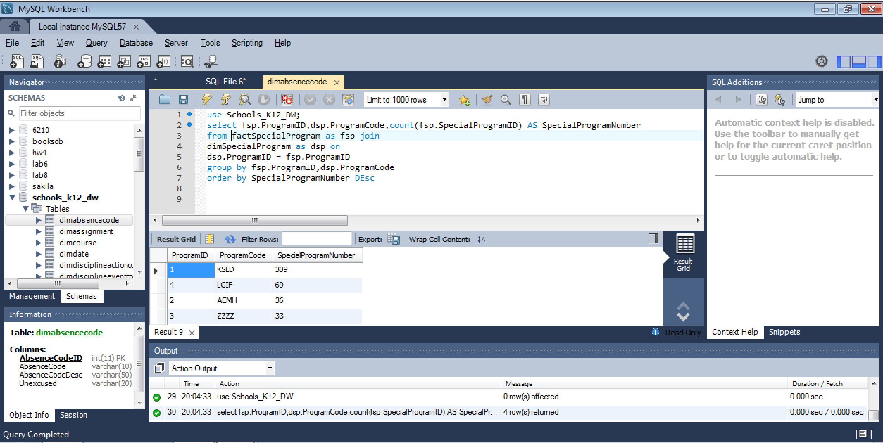

4.3 Special Programs from parents perspective:

For each grade, How many student attend special programs in year of 2010

use Schools_K12_DW;

select ds.Grade,count(fsp.StudentID) AS StudentNumber

from factSpecialProgram as fsp join

dimStudent as ds on

ds.StudentID= fsp.StudentID

where year(fsp.EntryDate) = '2010'

group by ds.Grade

